Module 3 End Assignment : Static Resume Web Application using Django

- Function is been created in views.py
- All the content of the resume is been added inside the function
- A html file is created which is rendered to the function
- HTML file contains all styles for the content in the function
- Additional CSS file is been created to add style
- ../env/scripts/activate and python manage.py runserver is given in terminal to run the code in browser

Views.py

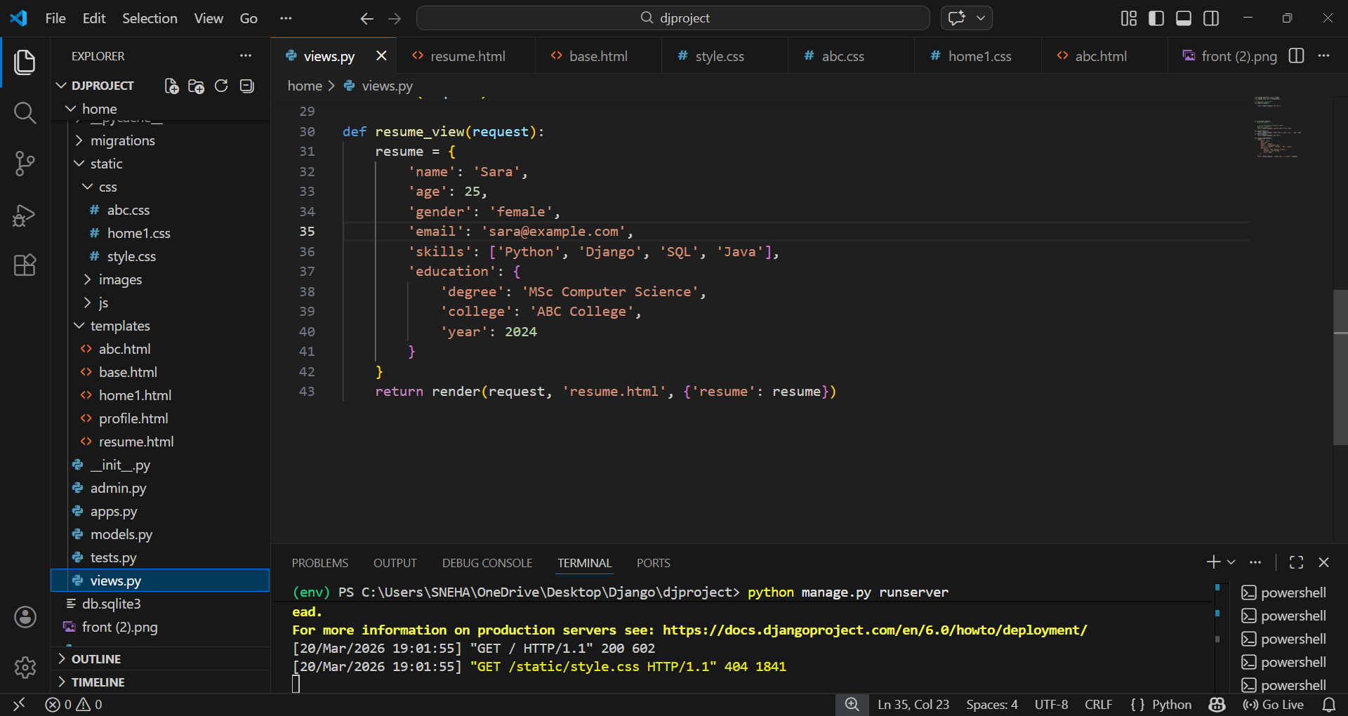

resume.html
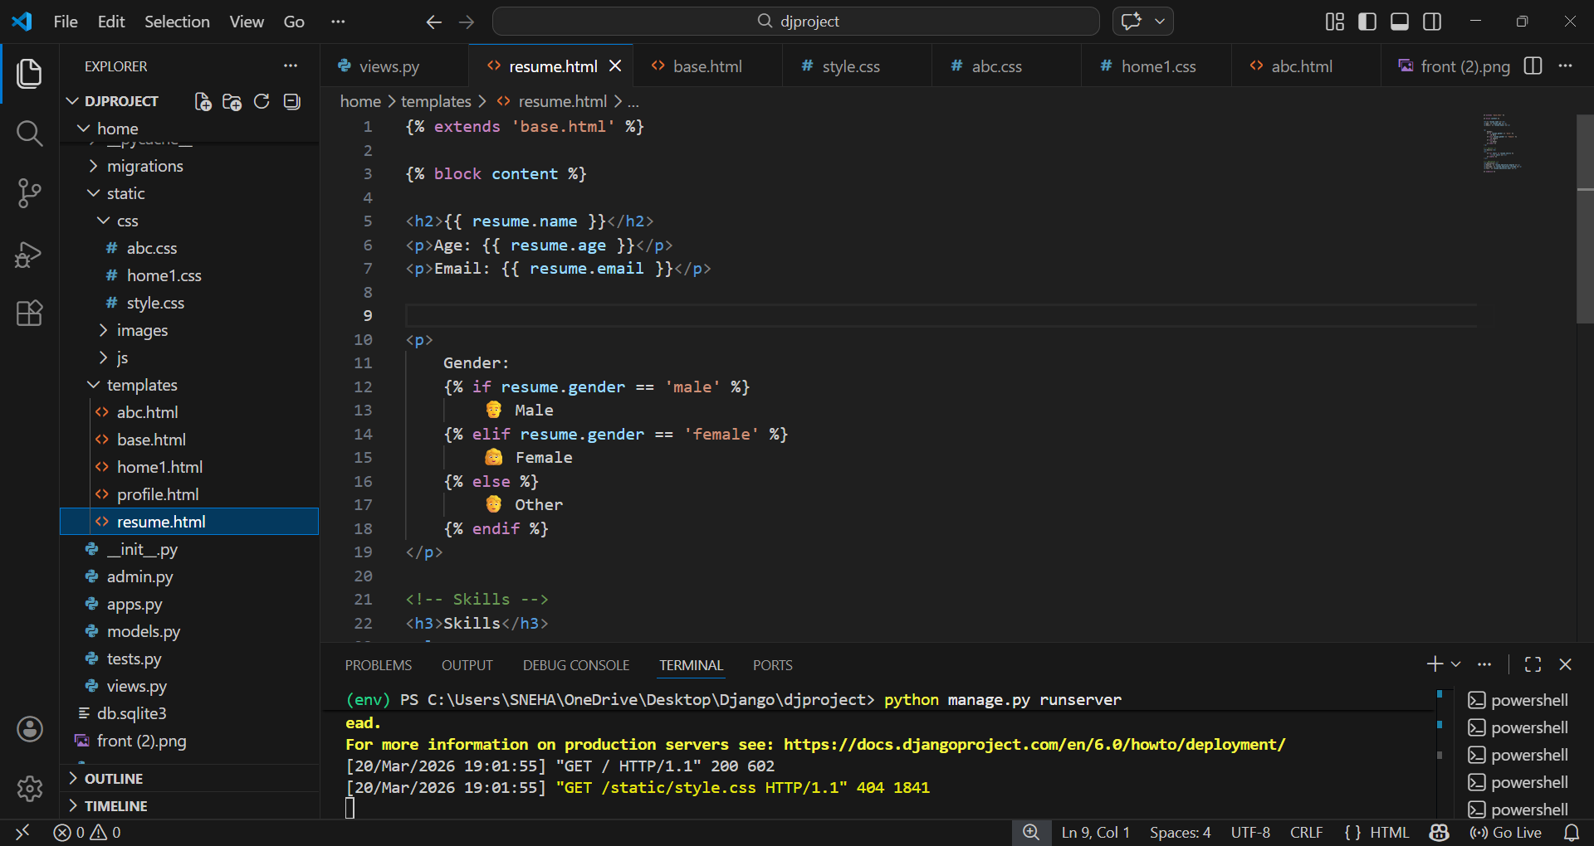

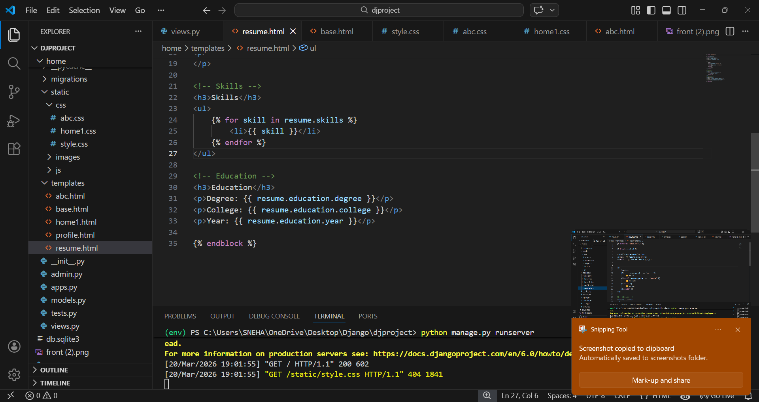

Style.css
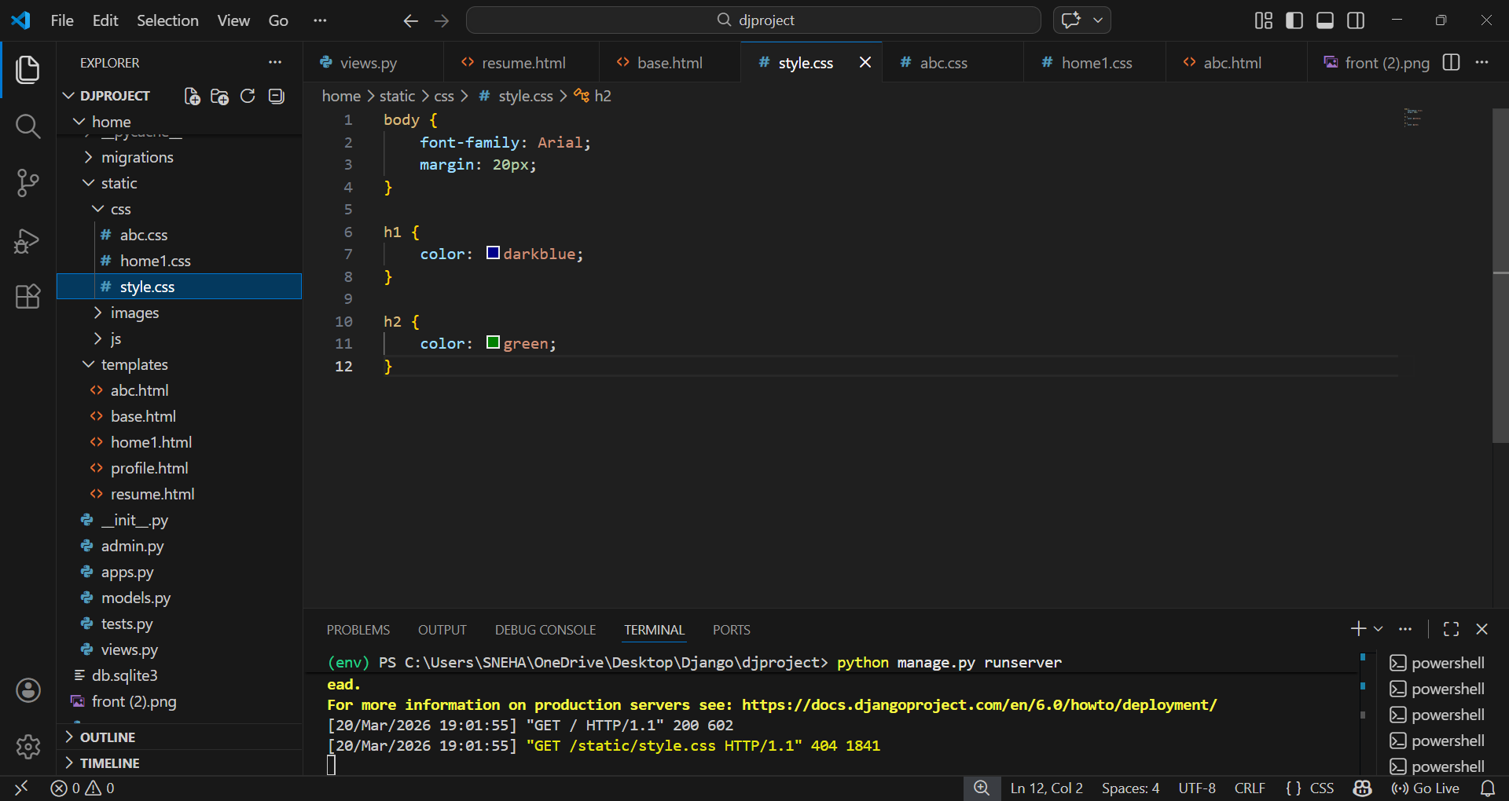

BROWSER PAGE
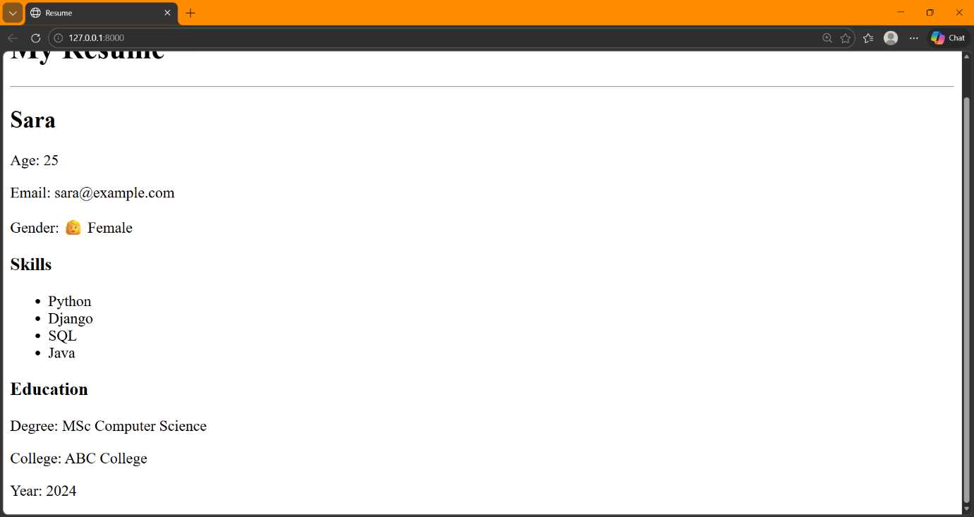

SUMMARY
- Have used templates of HTML and styling by creating CSS file
- For loop and if conditions is been used for gender and skills
- Path is been assigned to the function

CHALLENGES
- Usage of templates
- Usage of loops and conditions
LEARNING OUTCOMES
- Have learned to use Django to create resume
- Learned to style
- Learned to rectify errors

